SQL ASSIGNMENT

Question 1.1

Query the average population for all cities in **CITY**, rounded down to the nearest integer.

**Input Format**

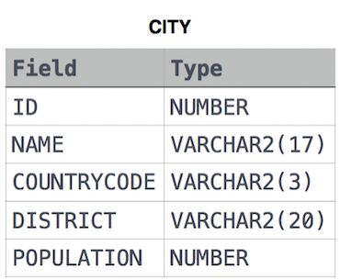The **CITY** table is described as follows:

Answer 1.1

SELECT Floor(AVG(POPULATION)) AS avg_popl

FROM CITY;

Output 1.1

Expected Output

* 454250

_____________________________________________________________________________

QUESTION 1.2

Query the sum of the populations for all Japanese cities in **CITY**. The COUNTRYCODE for Japan is **JPN**.

ANSWER 1.2

SELECT SUM(POPULATION) AS TOTAL_POPULATION

FROM CITY

WHERE COUNTRYCODE = 'JPN';

OUTPUT 1.2

Your Output (stdout)

* 879196

_____________________________________________________________________________

QUESTION 1.3

Query the difference between the maximum and minimum populations in **CITY**.

ANSWER 1.3

SELECT (MAX(population) - MIN(population)) AS Difference

FROM CITY;

OUTPUT 1.3

Your Output (stdout)

* 4695354

______________________________________________________________________________

QUESTION 1.4

Given the **CITY** and **COUNTRY** tables, query the names of all the continents (COUNTRY.Continent) and their respective average city populations (CITY.Population) rounded down to the nearest integer.

**Note:** CITY.CountryCode and COUNTRY.Code are matching key columns.

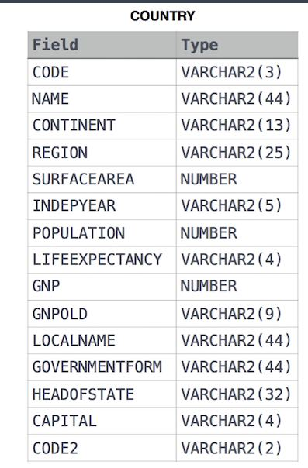

ANSWER 1.4

SELECT cou.continent, FLOOR(AVG(cit.population))

FROM COUNTRY AS cou

INNER JOIN CITY AS cit

ON cou.code = cit.countrycode

GROUP BY cou.continent;

OUTPUT 1.4

Your Output (stdout)

* Africa 274439
* Asia 693038
* Europe 175138
* Oceania 109189
* South America 147435

_____________________________________________________________________________